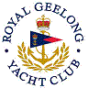 | Royal Geelong Yacht Club Inc.  Est 1859
Trophy Deed of Gift.

Trophy: | Foundation Trophy for Twilight Race
Presented by: | R G Y C Foundation.
Date: | Season 2012/2013
For: | Div 1 And Div 2 Winner of Event so Nominated
Remarks / Revisions
Click here for a List of Recipients

